Adverbs of Negation

🔹 What Are Adverbs of Negation?
# Source: AI Source: Provided by: [Data Path: Persons Table -> ID Column: 1, Name_En Column: Motasem Essam] -> From: [Chatgpt (GPT-4-turbo)] on [7/27/2025]
Adverbs of negation are used to express a negative meaning in a sentence.
They deny something, show disapproval, or indicate that something did not happen.
They answer the implied question: 👉 "Is it not true?" — and say NO, it is not.

✅ Common Adverbs of Negation
# Source: AI Source: Provided by: [Data Path: Persons Table -> ID Column: 1, Name_En Column: Motasem Essam] -> From: [Chatgpt (GPT-4-turbo)] on [7/27/2025]
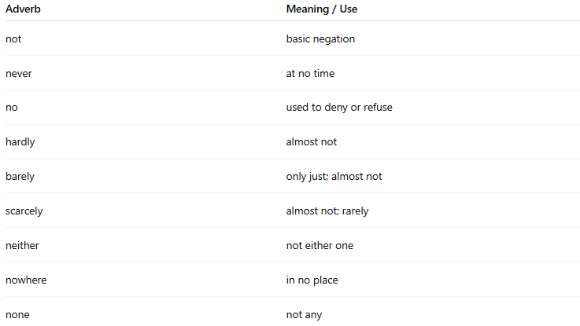
Adverb | Meaning / Use
not | basic negation
never | at no time
no | used to deny or refuse
hardly | almost not
barely | only just; almost not
scarcely | almost not; rarely
neither | not either one
nowhere | in no place
none | not any

📚 Examples in Sentences
# Source: AI Source: Provided by: [Data Path: Persons Table -> ID Column: 1, Name_En Column: Motasem Essam] -> From: [Chatgpt (GPT-4-turbo)] on [7/27/2025]
- She is not coming today.
- He never lies.
- I hardly slept last night.
- They scarcely noticed the noise.
- We found him nowhere.
- No, I don’t agree.
- Neither answer is correct.

🧠 Key Notes
# Source: AI Source: Provided by: [Data Path: Persons Table -> ID Column: 1, Name_En Column: Motasem Essam] -> From: [Chatgpt (GPT-4-turbo)] on [7/27/2025]
- "Not" is the most basic and frequently used negation adverb.
- These adverbs usually appear before or after the verb depending on the sentence structure.
- Some adverbs of negation (like never, hardly) already make the sentence negative, so no extra "not" is needed:
❌ I don’t never lie. (Incorrect — double negative)
✅ I never lie.

